2018: Average cover of Fucus in MID, West Beach: 30%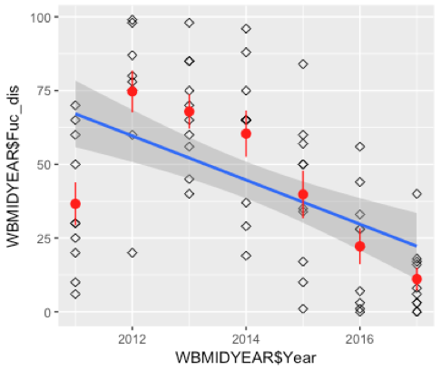

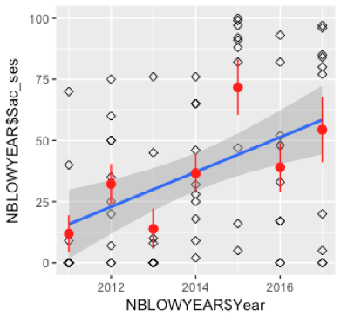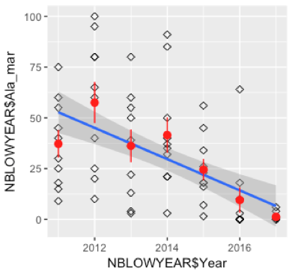

2018: Saccharina sessilis, Low, North Beach: 51%

Alaria marginata, Low, North Beach: 32%